PIPELINE PROJECT (CI/CD)

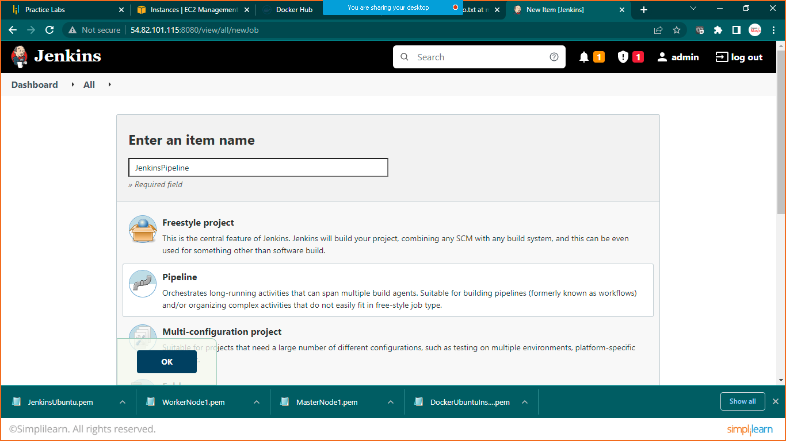

Select pipeline project

Link: https://github.com/Nikunj-Java/SpringBootDockerApp.git

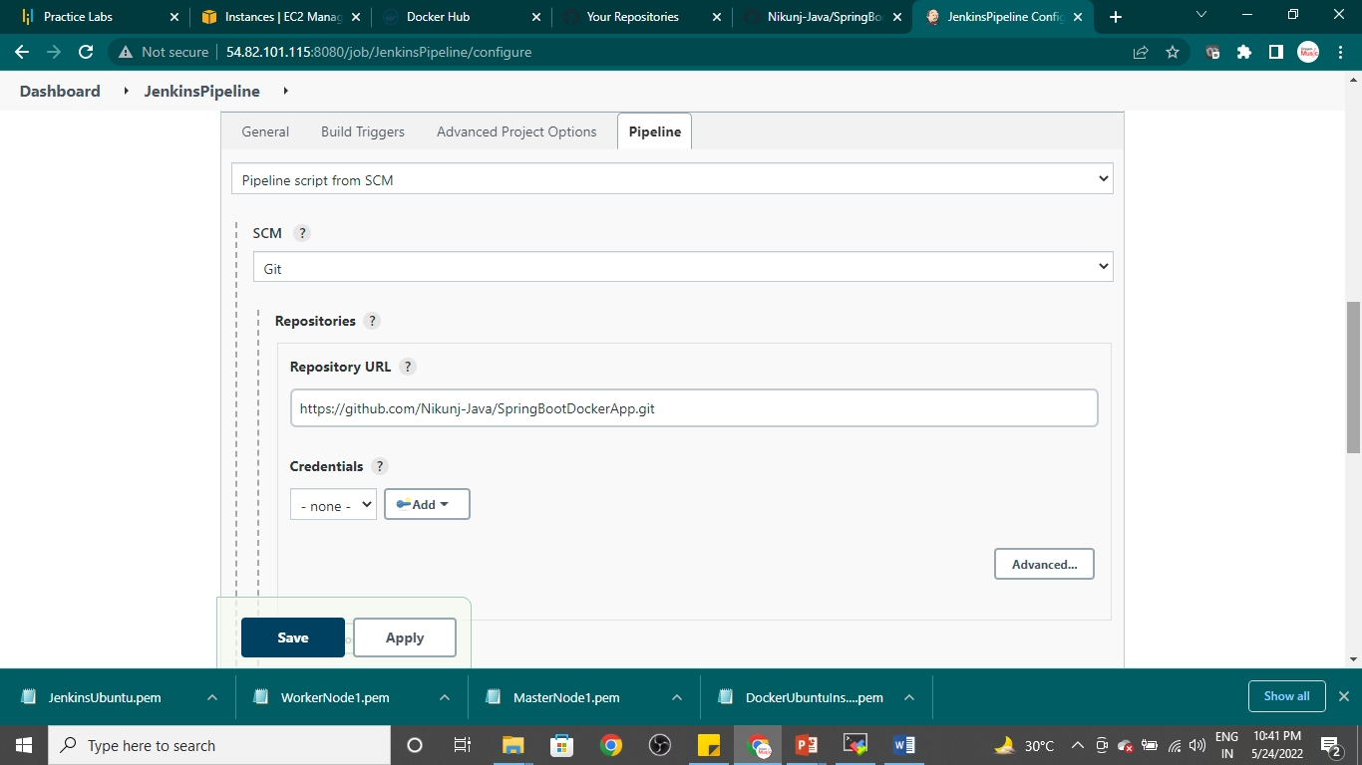

Save it click on build now

If you are getting permission denied error in build

Run below code:

sudo chmod 777 /var/run/docker.sock

click on Build Now

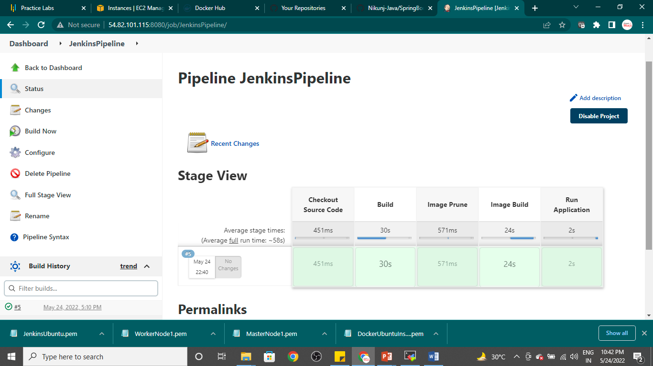

Goto moba xterm and run below code

Sudo docker images